Local publication for call for proposals
EU4Justice phase II - Support to Judicial Professionalism and the Fight against Organised Crime and Corruption in Bosnia and Herzegovina  Publication reference: EuropeAid/172315/DD/ACT/BA | 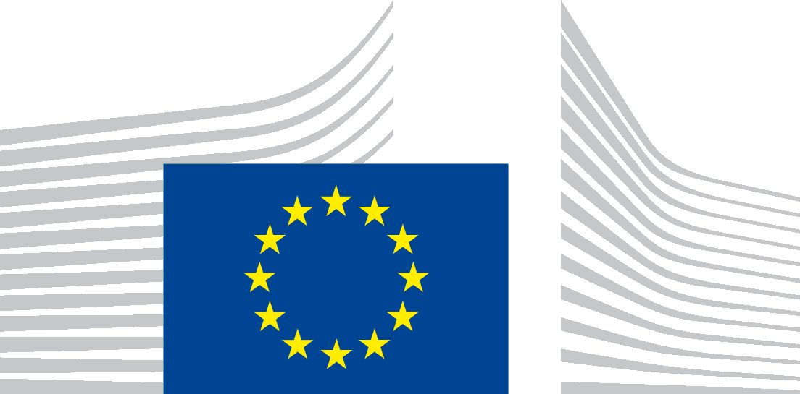
The Delegation of the European Union to Bosnia and Herzegovina (BiH) is seeking proposals to strengthen the rule of law in BiH, notably by enhancing the independence, quality, effectiveness, accountability, and efficiency in the BiH justice sector and its results in fight against corruption, with financial assistance from the Instrument for Pre-Accession (IPA II). The full guidelines for applicants are available for consultation on the following internet site: https://webgate.ec.europa.eu/europeaid/online-services/index.cfm?do=publi.welcome.
The deadline for submission of proposals is 14 September 2021 at 12:00 (time zone of Bosnia and Herzegovina).
An information session on this call for proposals will be held online on 15 July 2021. The conditions to participate to the information session are indicated in the guidelines for applicants.

